Research Section: React, ASP.NET Core Web API Communication
Table of Contents
Research Section: React, ASP.NET Core Web API Communication 1
Introduction 3
Axios 4
API Configuration 5
Authentication Flow 6
Sending Requests — The Service Layer 7
Receiving Responses 8
Error Handling 10
Cross-Origin Resource Sharing (CORS) 11
ASP.NET Identity and Role-Based Authorization 12
Summary 16

Introduction
The FitCore Gym Management System is a full-stack web application built on two distinct technologies: a React single-page application running in the browser, and an ASP.NET Core 8 Web API running on the server. These two are used to communicate reliably, securely, and efficiently. This research section explains how that communication is implemented

React and ASP.NET Core are separate applications, running on different ports during development, they do not share memory. Every interaction between them must happen over HTTP using JSON as the data format, with authentication carried by JWT tokens on every request.

This section covers:
- The choice of HTTP client (Axios)
- How requests and responses are structured
- How authentication is attached to every request
- How errors are handled consistently
- How Cross-Origin Resource Sharing (CORS) is configured

Axios
Because react does not include a built-in HTTP client a browser would provide native API’s, we specifically chose Axios over the native API for the following reasons:
- Cleaner syntax — Axios automatically parses JSON responses, so there's no need to call response.Json() on every request.
- Interceptors — Axios allows us to define functions that run before every request or after every response. This is essential for attaching JWT tokens automatically.
- Better error handling — Axios rejects promises on non-2xx HTTP status codes by default, making error handling more predictable.
- Wide adoption — Axios is the de facto standard in the React community, so documentation and examples are abundant.

API Configuration
ather than configuring Axios separately in every file, we create a single Axios instance in frontend/src/services/api.js. All services import this instance. This ensures:
- One place to set the base URL
- One place to attach authentication
- One place to add global error handling
- Consistency across the entire application
import axios from 'axios';
const api = axios.create({
baseURL: 'https://localhost:7001/api',
});
api.interceptors.request.use((config) => {
const token = localStorage.getItem('token');
if (token) {
config.headers.Authorization = `Bearer ${token}`;
}
return config;
});
export default api;

Explanation
- axios.create() — creates a reusable instance with shared configuration. Every request made through this instance automatically uses baseURL, so service files can call api.get('/members') instead of the full URL.
- interceptors.request.use(...) — a function that runs before every request is sent. It reads the JWT from localStorage and attaches it as an Authorization header. This means no service file ever has to remember to add the token — it happens automatically.

Authentication Flow
Step 1 — Login
The frontend sends a POST request to /api/auth/login with the user's email and password:
Step 2 — Token issued
The API validates the credentials against ASP.NET Identity. If valid, it returns a JSON response containing a JWT token and user information:

Step 3 — Token stored
The frontend stores both the token and the user object in localStorage:
Step 4 — Token attached to every subsequent request
Because of the Axios request interceptor, the Authorization: Bearer <token> header is automatically added to every request from that point onward.
Step 5 — Backend validates
The API's [Authorize] attribute validates the token and extracts the user's role from the JWT claims. If the token is invalid or expired, the API returns 401 Unauthorized. If the user's role does not match the required role, the API returns 403 Forbidden.
Step 6 — Logout
On logout, the frontend removes both keys from localStorage. Because the token is no longer present, the interceptor stops adding the header, and protected endpoints become inaccessible.

Sending Requests — The Service Layer
All API calls are wrapped in service files under frontend/src/services/. Each service exposes functions that match the API contract exactly. This layer isolates the rest of the frontend from the details of HTTP.
Example — from workoutTaskService.js:
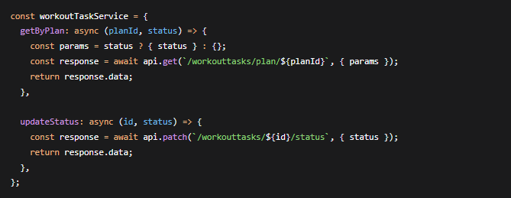

- api.get() sends an HTTP GET request.
- Path parameters are inserted directly into the URL, e.g. /workouttasks/${id}/status.
- Query parameters are passed as a params object. Axios converts them into ?status=InProgress automatically.
- response.data contains the parsed JSON body returned by the API.
- This pattern is repeated in every service: memberService.js, trainerService.js, programmeService.js, workoutPlanService.js, and workoutTaskService.js.

Receiving Responses
The API always returns JSON. ASP.NET Core serialises C# objects into JSON automatically and uses camelCase for property names (e.g. firstName, memberNumber, trainingProgrammeId). This matches JavaScript conventions, so the frontend can consume the data directly without any transformation.

C# DTO:

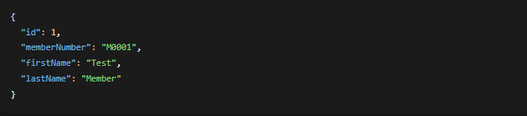
returned to the frontend:
React page then binds these properties directly into the UI:

Error Handling

A consistent error format is essential so that the frontend can display user-friendly messages. The API uses a standard error shape for all failures:

On the frontend, every service call is wrapped in a try/catch block. If the request fails, the error is caught and displayed to the user:

- try — runs the request.
- catch (err) — runs if the request fails (network error or non-2xx status).
- err.response?.data?.message — extracts the human-readable message from the API. The optional chaining (?.) prevents a crash if err.response is undefined (e.g. network failure).
- Fallback message — if no message is available, a generic one is used.

For form validation, the errors object is used to attach specific messages to specific fields

Cross-Origin Resource Sharing (CORS)
During development, React runs on http://localhost:3000 and the API runs on https://localhost:7001. Browsers block cross-origin requests by default for security reasons. To allow the frontend to reach the API, CORS must be configured on the backend.

WithOrigins("http://localhost:3000") — explicitly allows the React development server. In production, this would be replaced with the deployed frontend URL.
AllowAnyHeader() — permits the Authorization and Content-Type headers.
AllowAnyMethod() — allows GET, POST, PUT, PATCH, and DELETE.
AllowCredentials() — required if cookies or authorization headers are sent.
Without this configuration, the browser would block every request from React with a CORS error before it even reaches the API.

ASP.NET Identity and Role-Based Authorization
Authentication and authorization are handled by ASP.NET Identity combined with JWT Bearer tokens. This provides a stateless, scalable authentication mechanism suitable for a RESTful API.

ASP.NET Identity manages users, passwords, and roles. The ApplicationUser class extends IdentityUser:

roles are seeded at startup: Admin, Trainer, and Member.
JWT Token Generation
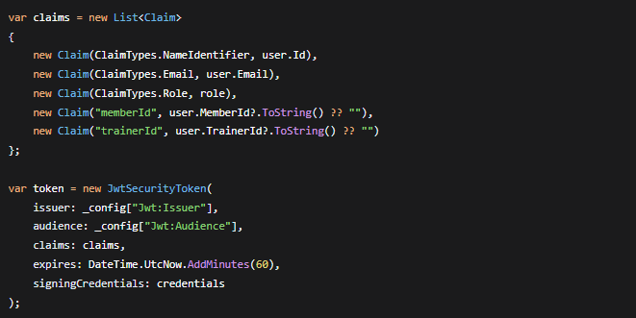
On successful login, the API generates a JWT containing claims for the user's ID, email, role, and associated entity IDs:


Protecting Endpoints
- If no valid token is provided → 401 Unauthorized
- If the token is valid but the role does not match → 403 Forbidden

Frontend Role Enforcement
The frontend uses a ProtectedRoute component that checks the user's role from localStorage before providing a route. If the user lacks the required role, they are redirected to an "Unauthorized" page. This provides a better user experience but is not a security measure. Only the API enforces the real authorization.

Search Functionality
Backend Implementation
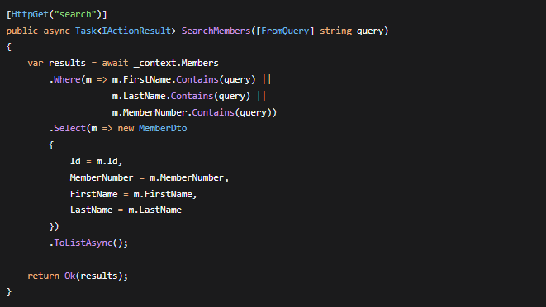
Search is implemented server-side using Entity Framework Core's Where and Contains methods. For example, searching members by name, surname, or member number:

Frontend Implementation

The frontend sends the search term as a query parameter and displays the results:
Entity Framework Core Relationships
One-to-Many Relationships
The system implements the following one-to-many relationships using EF Core Code-First:
Relationship | Description
Trainer → Members | One trainer can be assigned to many members
TrainingProgramme → Members | One programme can be assigned to many members
TrainingProgramme → WorkoutPlans | One programme can contain many workout plans
Member → WorkoutPlans | One member can have many workout plans
Trainer → WorkoutPlans | One trainer can create many workout plans
WorkoutPlan → WorkoutTasks | One plan can contain many tasks

Example — WorkoutPlan and WorkoutTask:
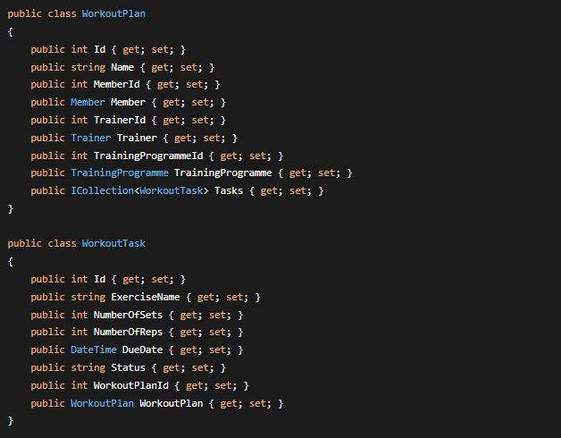
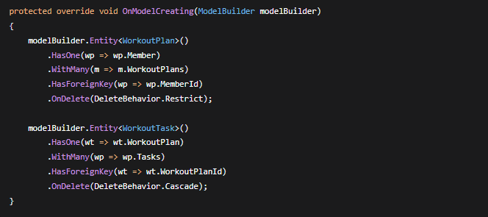
Configuring Relationships in DbContext

One-to-Zero-or-One Relationships

ApplicationUser has optional one-to-zero-or-one relationships with Member and Trainer

Migrations
EF Core Migrations are used to create and update the database schema:

Summary
This research summary documents the key technical and implementational decisions used to enable the FitCore Gym Management System's React frontend to communicate securely and efficiently with its ASP.NET Core 8 Web API backend. Axios with interceptors provides automatic JWT attachment, the service layer isolates HTTP concerns, consistent error handling ensures a good user experience, and CORS configuration allows cross-origin requests during development. Combined with ASP.NET Identity for authentication, role-based authorization for security, EF Core for data relationships, and server-side search functionality, our system provides a robust, and maintainable full-stack solution, which can also be easily scaled to meet increasing member numbers at FitCore Gym

